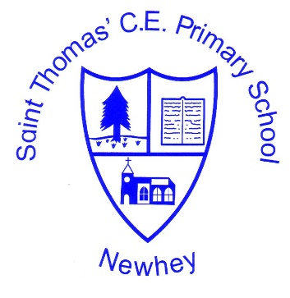
The Little School with the Big Heart
‘With God All Things are Possible’ Matthew 19:26
PSHE Vocabulary

EYFS

Same, different, friends, family, special, favourite, help, feelings, happy, excited, sad, upset, angry, kind, caring, safe, unsafe, body, trust, online, resilient, fail, can, can’t, try, food, strong, energy, healthy, sleep, germs, exercise, seasons, cycle, babies.

KS1

Jobs, responsibilities, behaviour, rules, comfortable, uncomfortable, feelings, emotions, happy, angry, sad, fearful, surprised, nervous, worried, safe, safety, controlled, body, mind, hurt, adults, trust, special, friends, family, conflict, resolution, qualities, difference, relationships, behaviour, teamwork, tolerance, racism, cooperation, caring, same, different, fair unfair, respect, unkind, teasing, bullying, rules, laws, thoughtful, generous, food, strong, energy, healthy, clean, unclean, hygiene, sleep, germs, exercise, regular, important, medicine, environment, resilient, fail, can, can’t, difficult, portion, fruit, vegetable, baby, toddler, adult, grow, change, appropriate, inappropriate, good touch, bad touch, red/green areas, money, sensible, Growth Mindset, goals, aspirations, praise, dream, secrets, privates (incl. NSPCC Underpants Rule).

KS2

Listen, agree, disagree, resolve, argue, argument, dispute, communities, tolerance, diversity, respectful, needs, emotional needs, example, risk, risky, situation, cigarettes, alcohol, medicine, health, influence, online, personal details, share, information, communication, cyber, opinion, fact, false facts, responsibility, health, benefits, talents, skills, goals, goal-setting, careers, aspirations, improve, resilience, achieve, positive negative, human, egg, sperm, body space, comfortable, uncomfortable, body language, assertive, religion, faith, culture, differences, tolerance, stereotyping, racism, labels, challenge, influence, media, celebrity, image, body image, awareness, self-awareness, confidence, Growth Mindset, choice, harmful, positive, negative, selective, accurate, inaccurate, media, cyber, trolls, environment, bystander, active, rights, responsibilities, witness, biased, money, limited resource, generations, future, puberty, marriage, civil ceremony, couples, gender, same-sex, law, parental consent, consent, aggressive, passive, response, ignorance, misunderstanding, external, internal, male, female, develop, puberty, FGM, menstruation, sex, labour, birth, conceive (see below), HIV, immune system.

Menstruation/puberty/sex appears in the Y3 and Y4 curriculum (Unit 6 Growing and Chaninging), however puberty lessons actually appear in the Y5 curriculum and sex appears in the Y6 curriculum:
Year 3 and 4:
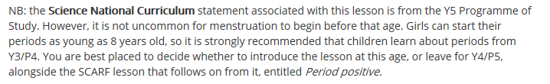
Year 6:
