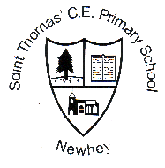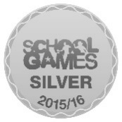
St. Thomas’ C.E. Newsletter
Week 18 3rd February 2017

Monday 6th February | Music lessons: guitar, keyboard, strings  After School Activities: football for years 4, 5 and 6 choir,
Tuesday 7th February | Yoga and relaxation for adults and children from 8.15am  Mediquip4kids assembly  Police dog visit for class 2 at 9.45am  Mini-Olympics at Wardle for KS1 (selected children)  Football Tournament at Soccer Village for selected children
Wednesday 8th February | Swimming lessons start for class 4.  After School Activities: Orchestra
Thursday 9th February | Music lessons: guitar  After School Activities: football for years 1,2 and 3
Friday 10th February | Music lessons: brass and woodwind

Stars of the Week
Will be published next week.
Class Attendance Award
This week’s winner is class 3 with 98.4%. Well done.

This Week’s Worship Focus
This half term our focus is Respect. This week we are focussing on how God made us all different and those differences should be respected and celebrated.

Dogs
Dogs are not permitted on the school playground unless they are assistance dogs.
In addition, we respectfully request that dogs should be kept away from the school gate on the Lane. Some of our children have a fear of dogs and they are struggling to walk past the dogs that are near the gate. If you do bring your dog with you, please stand to the right of the gate going up the hill so that scared children do not need to walk past them. Thank you.

Class 4 Swimming
Class 4 begin compulsory swimming lessons on Wednesday 8th February. Swimming is part of the National Curriculum and all children must attend.
The swimming baths has relaxed its policy on boy’s swimwear and they can now wear swimming shorts, which must have a net inside, and must be shorter than knee length and not be baggy. If the instructors feel the swimwear is inappropriate, the child will not be allowed to swim.

Reminder
School closes for the half-tem holiday on Thursday 16th February.

