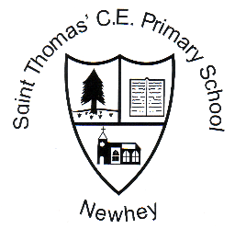
St. Thomas’ C.E. Primary School

Week 10 | Friday 17th November 2017

Monday 20th November | After school activities: choir  Running club 12.30pm  Daily mile at 1.15pm
Tuesday 21st November | Music lessons: ukulele and clarinet  After school activities: football (years 4, 5 and 6)
Wednesday 22nd November | Music lessons: violin  Class 3 visit to Manchester  Daily mile at 1.15pm  After school activities: orchestra
Thursday 23rd November | Music lessons: guitar  Class 2 visit to Touchstones  Football Tournament at Soccer Village for years 3 and 4  After school activities: football (years 1, 2 and 3)
Friday 24th November | Music lessons: keyboards, brass  After school activities: film club

Stars of the Week
Abigail Clegg, Noah Hill, Freya Green, Kylian Gomis, Amelia Cooper, Freya Crowther, Alex Lincoln, Lucas Goulding, All of class 4, Destiny Ali and Maddison Roberts.

Achievements Outside of School
Molly Stewardson for passing the Manchester Cathedral Choir audition

Attendance Trophy
Class 5 are this week’s winners with 99.37% attendance.
Well Done.
Class 1 – 98.57%
Class 2 – 96.60%
Class 3 – 94.29%
Class 4 – 99.03%

The average attendance for school this week is 97.6% - the highest average for a while – well done class 1 for making a marked improvement.

Parking
Parking around school is improving – thank you for your support in making the roads around school safer for all of our children.
Our ‘Walking Warriors’ group met with Dan on Thursday to begin the parking project. They have so far identified places where they do not want parents to park and they have also found possible local alternatives.

Dinner Money, School Trip and Winmarleigh Hall consents.

There are a higher than usual number of outstanding dinner money bills that need to paid as soon as possible.

In addition, the office staff have reported that there are outstanding consents and contributions for school trips and Winmarleigh Hall.

Frost Quiz Night

Friday 24th November is the FRoST family fun night – complete with bingo, games and a quiz. Tickets cost £3.00 per adult and £1.00 per child. Refreshments will be provided. However, there is no licence – but you can bring your own. Tickets are available from the school office.

Church Christmas Activities

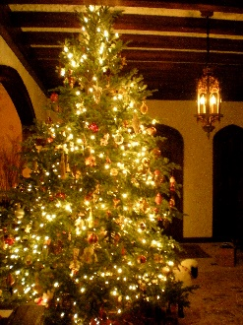

The Church are holding a Christmas Tree Festival on Saturday 9th December – this is instead of their usual Village Fair. There will still be some activities – such as the chocolate tombola and bottle stall. Our school choir will be singing and the school will be entering a Christmas Tree.

The Christingle Service will be held on Sunday 10th December at 3.00pm in the church. Children will soon be receiving a Christingle collection box to fill with coins to take with them to the service. This money supports the Children’s Society.

School Spider
The app has been updated by the school spider team so that it runs more smoothly.
I struggled to download the new version and get it to work on my iphone. I solved the problem by turning my phone off and then back on after I had downloaded the app. Since then I have had no trouble and all messages are coming through fine.
In addition, please note that when selecting the school there are two St. Thomas’ on the list. Our school is the second one – ST. Thomas’ Church of England Primary.

