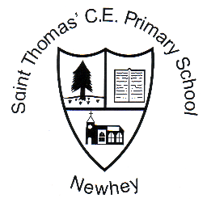
St. Thomas’ C.E. Primary School

Week 19 | Friday 26th January 2017

Monday 29th January | After school activities: Choir until 4.15pm  Music lessons: ukulele and guitar  Daily mile at 1.15pm
Tuesday 30th January | Mini-stars athletics at Hopwood Hall for years 1 and 2  After school activities: Lacrosse
Wednesday 31st January | Music lessons: violin and clarinet  After school activities: Orchestra
Thursday 1st February | Music lessons: guitar  Year 6 Gifted and Talented Writers day 2  After school activities: football (years 1, 2 and 3)
Friday 2nd February | Music lessons: keyboards, brass  Class 4 visit to Touchstones  After school activities: Playmaker

Stars of the Week
Elena Lowe, Charlie Woodhouse, Neve Prince, Toby Reynolds, Miller McKeown, Alex Lincoln, Max Paul-Moore, Charlie Wild

Attendance Trophy
Class 43 are this week’s winners with 98.57% attendance.
Well Done.

Class 1 – 88.62%
Class 2 – 87.33%
Class 4 – 98.57%
Class 5 – 95.31%

Average attendance is 93.68%. This is way short of the target.

Spellings

All children in school are given weekly spellings to practise at home – this includes all reception children.
The current curriculum and assessment system places a high importance on spelling. This year spelling is our highest priority on the school development plan. Children cannot attain age expected outcomes for writing if they struggle with spellings.
I will be hosting an evening workshop for parents in March based around spelling expectations and how you can help at home.

Sports Round-Up

Swimming
Children from years 4 and 5 took part in a swimming gala at Castleton Baths this week. They all did an amazing job. The girl’s team came second and the boys came first –securing a place at the finals on February 8th. Well done!

Dinner Money
Please can all outstanding dinner/music money be sent into school as soon as possible. Thank you

