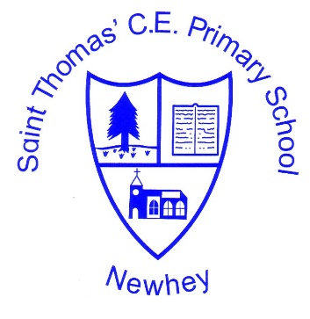
The Little School with the Big Heart
‘With God All Things are Possible’ Matthew 19:26
History
Intent | Implementation | Impact
Our aims are to ensure that our pupils experience a wide breadth of study and have, by the end of each key stage, long term memory of an ambitious body of procedural and semantic knowledge.  Our history curriculum is derived from an exploration of the backgrounds of our pupils, our beliefs about high quality education and our values. They are used to ensure that we give our students appropriate and ambitious curriculum opportunities.  Cultural capitol gives our students the vital background knowledge to become informed and thoughtful members of our community who understand British Values.  Our curriculum distinguishes between subject topics and threshold concepts. The subject topics being the specific aspects of subjects that are studied and threshold concepts tie the subjects into meaningful schema.  The threshold concepts are divided into three milestones which provide a progression model. Knowledge categories in each subject give students a way of expressing their understanding of the threshold concepts.  With each milestone, students gradually progress in their procedural fluency and semantic strength through three cognitive domains – basic, advancing and deep. The gaol is for students to develop mastery by the end of each milestone.  As part of the progression model we sue POP tasks (proof of progress) which show curriculum expectations in each cognitive domain. | Our history curriculum design is based on evidence from cognitive science. It is underpinned by three main principles: spaced repetition, interleaving of topics and retrieval of previously learned content which is regular and frequent.  We recognise that learning is invisible in the short term and sustained mastery takes time.  The content is subject specific. We do make cross-curricular links where appropriate.  We base our history curriculum of Chris Quigley’s History companion. | Because learning is a change to long-term memory, it is impossible to see impact in the short term. However, we do use assessment based on deliberate practice. This means that we look as the practices taking place to determine whether they are appropriate, related to our goals and likely to produce results in the long run  We use comparative judgement in the tasks we set and in comparing pupil’s work over time.  We use lesson observations to see of the pedagogical style matches our expectations.

