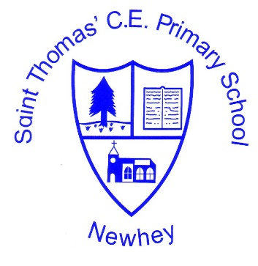
The Little School with the Big Heart
‘With God All Things are Possible’ Matthew 19:26
History Skills and Knowledge Progression
 | KS1 (milestone 1) |  | Milestone 2 |  | Milestone 3
 | Class 1 (EYFS/Year 1) | Class 2  (Year 1/Year 2) | Class 3  (Year 2/year3) | Class 4  (Year 4/year 5) | Class 5  (year 5/year 6)
Investigate and Interpret the past | Observe or handle evidence to ask questions and find answers to questions about the past.  Ask questions such as: ‘what was it like for people? What happened? How long ago?  Identify some of the different ways the past has been represented  Use artefacts, pictures, stories, online sources and databased to find out about the past. |  | Use evidence to ask questions and find answers to questions about the past  Suggest suitable sources of evidence foe historical enquiries  Use more than one source of evidence for historical enquiry in order to gain a more accurate understanding of history  Describe different accounts of an historical event, explaining some of the reasons why the accounts may differ.  Suggest causes and consequences of some of the main events and changes in history |  | Use sources of evidence to deduce information about the past  Select suitable sources of evidence, giving reasons for choices.  Use sources of information to form testable hypotheses about the past.  Seek out and analyse a wide range of evidence in order to justify claims about the past  Show an awareness of the concept of propaganda and how historians must understand the social context of evidence studied.  Understand that no single sources of evidence gives the full answer to questions about the past  Refine line of enquiry as appropriate.
Build and overview of World History | Describe historical events  Describe significant people form the past  Recognise that there are reasons why people in the past acted as they did |  | Describe changes that have happened in the locality of the school throughout history.  Give a broad overview of life in Britain: from Ancient to Medieval times  Compare some of the times studies with those of other areas of interests around the world  Describe social, ethical, cultural or religious diversity of past society  Describe the characteristic features of the past, including ideas, beliefs, attitudes and experiences of men, women and children. |  | Identify continuity and change the history of the locality of the school.  Give a broad overview of life in Britain and some major events from the rest of the world.  Compare some of the times studies with those of other areas around the world.  Describe the social, ethnic, cultural or religious diversity of past society.  Describe the characteristic features of the past, including: ideas, beliefs, attitudes and experiences of men, women and children.
Understanding Chronology | Place events and artefacts in order on a timeline  Label timelines with words or phrases such as: past, present, older, newer  Recount changes that have happened in their own lives. |  | Place events, artefacts and historical figures on a timeline using dates  Understand the concept of change over time, representing this, along with evidence, on a timeline  Use dates and terms to describe events. |  | Describe the main changes in a period of history (using terms such as: social, religious, political, technological and cultural)  Identify periods of rapid change in history and contrast them with times of relatively little change.  Understand the concepts of continuity and change over time, representing them, along with evidence on a timeline.  Use dates and terms accurately in describing events.
Communicate historically | Use words and phrases such as:  - A long time ago  - Recently  - When my parents/carers were children  - Years, decades and centuries to describe the passing of time  Show an understanding of concepts such as:  - Nation and nation’s history  - Civilisation  - Monarchy  - Parliament  - Democracy  - War and peace |  | Use appropriate historical vocabulary to communicate including:  - Dates  - Time period  - Era  - Change  - Chronology  Use literacy, numeracy and computing skills to a good standard to communicate information about the past. |  | Use appropriate historical vocabulary to communicate including:  - Dates  - Time period  - Era  - Change  - Chronology  - Continuity  - Century  - Decade  - Legacy  Use literacy, numeracy and computing skills to a good standard to communicate information about the past.  Use original ways to present information and ideas.

