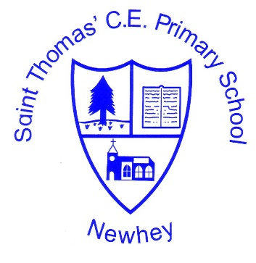
The Little School with the Big Heart
‘With God All Things are Possible’ Matthew 19:26
History Vocabulary
KS1 |  | KS2
Class 1 (EYFS/Year 1) | Class 2  (Year 1/Year 2) | Class 3  (Year 2/year3) | Class 4  (Year 4/year 5) | Class 5  (year 5/year 6)
Milestone 1  Observe  Artefact  Represent  Past  Present  Future  Recount  Appropriate  Recent  Year  Decade  Century  Nation  Civilisation  Monarchy  Parliament  Law  Democracy  Steamship  Heroine  Gallantry  Significant  Society  Monarch  Monarchy  Legacy  Politics  Memorial  Insanitary  Improved  Conditions  Legacy  Influential  Activist  Law  Segregation  Boycott  Race  Discrimination  Decade  Government  Tradition  Coronation  Exploration  Plaque  Internet  Communication  Significant  Houses of Parliament  Conspirators  Persecuted  Treason  Eyewitness  Extract  Architects  Congested  Transportation  Turbine  Locomotives  Consequence  Agricultural  Transmission  Ancient  Discoveries  Sustained  Influential  Orbit  rivals |  | Milestone 2  Source  Evidence  Historical  Sources  Primary source  Account  Secondary source  Enquiry  Historical enquiry  Cause  Consequence  Locality  Overview  Ancient  Medieval  Culture  BCE  CE  Social  Ethnic  Society  Change  Concept  Represent  Ancestors  Climate  Nomadic  Communal  Historical sources  Scavenging  Migrate  Permanent  Predators  Archaeologists  Sophisticated  Processions  C.:  Society  Custom  Hoard  Preserved  Intricate  Communal  Legacy  Fortified  Dominant  Fortifications  Inhabited  Surplus  Territories  Emperor  Sanitation  Resistance  Preservation  Erosion  Mosaics  Construction  Collapse  Conquered  Chaos  Christianisation  Pagan  Literature  Scandinavia  Explorers  Colonised  Evidence  Raid  Volatile  Descendant |  | Milestone 3  Suitable  Hypothesis  Testable  Reliable  Culture  Racial  Diverse  Characteristic features  Analyse  Justify  Propaganda  Bias  Culture  Influential  Fertile  Irrigation  Immortality  Canopic jars  Rituals  Decipher  Sarcophagus  Mummy  Engineering  Commemorate  Afterlife  Preserve  Embalmed  Eternity  Pharaoh  Democracy  Philosophy  Generation  Demigods  Lekythos  Amphora  Acoustics  Prosperous  Depicted  Arabesques  Renowned  Tolerance  Caliphate  Research  Missionary  Era  Silk road  Empire  Revolution  Economy  Parliament  Raj  Communism  Evacuated  Amphibious  Blitz  Atomic  Holocaust  Legacies  Declaration  Dispute  Rationing

