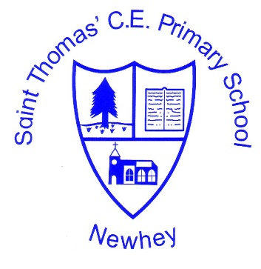
The Little School with the Big Heart
‘With God All Things are Possible’ Matthew 19:26
 | Autumn 1 | Autumn 2 | Spring 1 | Spring 2 | Summer 1 | Summer 2
Class 1 | Describing Maps of the World |  | The United Kingdom |  | Weather and climate
Class 2 (cycle 1 2020-2021 | Describing Maps of the World | Continents and Oceans | The United Kingdom  England, Scotland, Northern Ireland, Wales |  | Australia (Aboriginal People, Animals, Great Barrier Reef, Daintree Rainforest)
Class 2 (Cycle 2  2021-2022 | United Kingdom:  Capital Cities and Manchester |  | Describing maps of the World | Continents and Oceans | Weather and Climate
Milestone 1
Class 1 to focus on the ‘basic’ elements of the planning. Class 2 to focus on Advancing and Deep elements of the planning.
The planning and further support is found on the accompanying Milestone 1 PDF.

