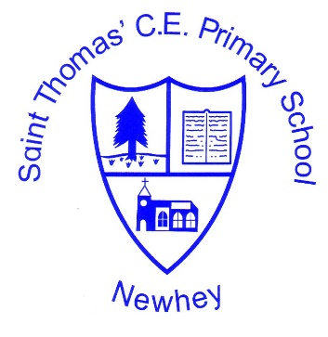
The Little School with the Big Heart
‘With God All Things are Possible’ Matthew 19:26
 | Autumn 1 | Autumn 2 | Spring 1 | Spring 2 | Summer 1 | Summer 2
Class 3 (cylcle 1 2020-2021 | Describing maps of the World 3 | Landscapes: weathering | Europe (population) | Landscapes: mountains | Landscapes: Rivers | Water Cycle
Class 3 (Cycle 2  2021-2022 | Describing maps of the World 3 | Erosion and deposition: coasts | Earthquakes and Volcanoes  (tectonic plates) |  | Transportation: international
Class 4 (Cycle 1  2020-2021 | Describing maps of the World 3 | Water Cycle | Europe (rivers and Mountains) |  | International Trade : Food, Natural Resources, Tourism
Class 4 (Cycle 2  2021-2022 | Describing maps of the World 3 | Erosion and deposition: Rivers | Erosion and deposition: management | Landscapes: weathering | Earthquakes and Volcanoes  (Pacific Ring of Fire and Impact)
Milestone 2
Class 3 to focus on the ‘basic’ elements of the planning. Class 4 to focus on Advancing and Deep elements of the planning.
The planning and further support is found on the accompanying Milestone 2 PDF.

