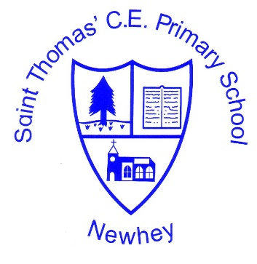
The Little School with the Big Heart
‘With God All Things are Possible’ Matthew 19:26
 | Autumn 1 | Autumn 2 | Spring 1 | Spring 2 | Summer 1 | Summer 2
Class 5 (cycle 1 2020-2021 | Using Maps  Grid references (4 and 6) |  | North America |  | Biomes  Temperate Deciduous Forest  Tundra  Marine
Class 5 (Cycle 2  2021-2022 | Using Maps  Grid references (4 and 6) |  | South America |  | Biomes  Freshwater  Savannah  Taiga
Milestone 3 Geography

