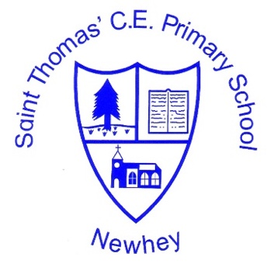
The Little School with the Big Heart
‘With God All Things are Possible’ Matthew 19:26
Computing
Intent | Implementation | Impact
Our computing curriculum aims to arm children with the knowledge to become socially responsible digital citizens. We want children to recognise that technology can support and enhance many different aspects of life and learning. We also aim to make children aware that as participants in the digital world, being digitally literate gives huge advantages to many future workplaces. We want children to have strong knowledge of the principles of computation and digital systems in order to apply this knowledge when programming.  We aim to give children a wide variety of experiences using different programmes. We want children to be able to creatively use their computational thinking to solve problems and develop their understanding of the world around them.  We hope to combine the aspects of computing knowledge and the application of this through information technology to show children the transformative power of technology. It is also essential that children know how to keep safe when using technology in order for them to delve into the digital world safely and responsibly.  We recognise the ever-increasing importance of digital literacy and the strong need to prepare children to become versatile and independent users of technology. | We implement a curriculum that is progressive throughout the whole school. Computing is a foundation subject in the National Curriculum and implementation of the computing curriculum is in line with 2014 Primary National Curriculum requirements for KS1 and KS2 and the Development Matters in EYFS. This provides a broad framework and outlines the knowledge and skills taught in each key stage.  We deliver the requirements of the National Curriculum through half-termly units. To deliver Computing we use Purple Mash, this covers a range of areas such as Information Technology, Computer Science and Digital Literacy.  Technology is also used throughout our other subjects through the use of iPads, laptops, interactive whiteboards and bee bots. In EYFS there is a computer which is available for the children to access independently on a daily basis.  Every academic year each class has a lesson with a Curriculum Advisor who brings in some new technology for the children to try and experience.  Pupils are encouraged to use Purple Mash at home and their independent logins are sent home. | We measure impact through:  - Teacher assessment  - Tracking pupil’s work on Purple Mash  - Checking the children’s abilities against the standards  - Children’s ability to use the skills in other tasks using technology.

