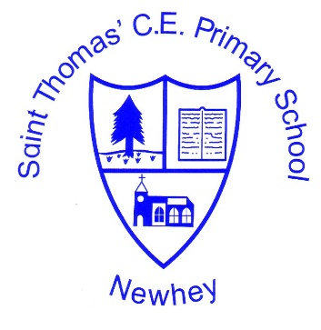
The Little School with the Big Heart
‘With God All Things are Possible’ Matthew 19:26
PHSE
Intent | Implementation | Impact
PSHE enables our children to become healthy, independent and responsible members of society. It aims to help them understand how they are developing personally and socially, and tackles many of the moral, social and cultural issues that are part of growing up. We provide our children with opportunities for them to learn about rights and responsibilities and appreciate what it means to be a member of a diverse society. Our children are encouraged to develop their sense of self-worth by playing a positive role in contributing to school life and the wider community. | At St Thomas’ we deliver the PSHE curriculum by utilising first-hand experience and sharing good practice and it is every staff members responsibility to do this by being a role model and having high expectations of St Thomas’ pupils.  All staff should actively promote, ‘Random Acts of Kindness’ and celebrate these with the children.  The delivered curriculum (scheme of work) reflects the needs of our pupils and is tailored to meet specific needs. We expect teachers to use the PSHE programme to equip pupils with a sound understanding of risk and with the knowledge and skills necessary to make safe and informed decisions.  The curriculum is split into three core themes of: Health and Wellbeing, Relationships and Living in the Wider World. The children will meet these themes throughout the course of the year and the themes are built upon as the children move through school.  In EYFS, KS1 and LKS2 children use their PHSE book to record their responses to and progress in PSHE sessions. These books travel with the children as they move to the next year group so they can look back at their learning and the next teacher can see the starting points. Their books show a learning journal.  Through the programme of study the children should have a good balance of these overarching concepts:  Identity  Relationships  A healthy, balanced lifestyle,  Identification of risk and safety  Diversity and equality  Rights, responsibilities and consent  Change and resilience  Power  Career  At St Thomas’ we believe that PSHE plays a vital part of primary education and needs to be taught at least weekly; although there will also be opportunity to make cross curricular links and these opportunities should not be missed. This enables staff to ensure full coverage of the PSHE scheme of work. There are always occasions where staff may feel it necessary to teach PSHE as a result of an issue which has arisen in their own class.  PSHE is integral to the development of children’s values in order for them to become a positive citizen in a forever changing community.  PSHE is an important part of school assemblies and collective worship were children’s spiritual, moral, social and cultural curiosity is stimulated, challenged and nurtured. | Children will achieve age related expectations in all areas of PHSE by the end of their cohort year.  Children will speak with clarity, expression and confidence to communicate their thoughts whilst also listening to those of others.  Children will develop good lifelong behaviour habits e.g manners and positive thoughts.  Children will be able to explain and discuss what they have studied in class.  Children will leave with strong moral, social skills and aware of culture issues.

