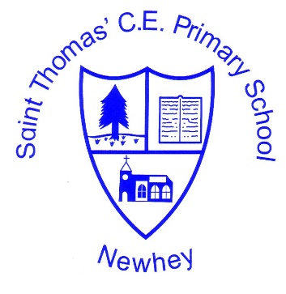
The Little School with the Big Heart
‘With God All Things are Possible’ Matthew 19:26
English
Intent | Implementation | Impact
We intend to deliver an English Curriculum which is designed to enable and empower children’s written and oral communication and creativity. Reading is the building blocks of learning and we aim to develop reading ability through fluency, comprehension and enrichment using high quality texts across all subjects. We seek to create purposeful writing opportunities within all areas of the children’s learning. | English is delivered as a discreet subject with lessons planned within a secure teaching sequence using a quality text as a starting point to develop the children’s speaking and listening, reading and writing skills. The teaching staff use CLPE’s The Power of Reading to plan their English lessons.  Within this teaching sequence children experience grammar and punctuation lessons. In many cases links will be made by the teacher to the topic being studied that term to give purpose to their final written outcomes.  Alongside this, children experience lessons in spelling, handwriting and reading. Our English is enhanced by learning spelling through the HeadStart Spelling Scheme; cursive handwriting and following our reading programme of high quality texts that is consistently used throughout the school.  Reading is largely delivered through whole class reading lessons, with some children having additional small group guided reading lessons.  The books that the children take home in EYFS and key stage 1 are closely matched to the daily phonics lessons and are all phonetically decodable.  Phonics is taught daily in EYFS and Key Stage 1 using Collins ‘Song of Sounds’ scheme.  Catch up programmes are delivered in a timely fashion. We use ‘CODE’ and ‘Beat Dyslexia’ and ‘Lexia’ to support children who are struggling.  To close the gap in EYFS with speech. Language and communication, the staff use Elklan and WELCOM programmes. | Children will achieve age related expectations in all areas of English by the end of their cohort year.  Children will speak with clarity, expression and confidence to communicate their thoughts whilst also listening to those of others.  Children will develop good lifelong reading habits e.g reading for pleasure and reading for information.  Children will read audibly, accurately and coherently, adapting their voice to suit a range of purpose, audience or text type.  Children will be able to explain and discuss what they have read having developed their inference and deduction skills.  Children will leave with a confident handwriting style and pace.  Children will incorporate a range of vocabulary in their speech and also in their writing.  Children will be secure with the conventions of writing.

