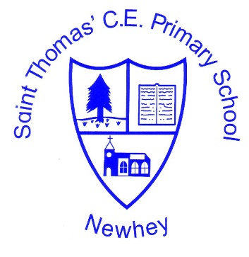
The Little School with the Big Heart
‘With God All Things are Possible’ Matthew 19:26
PE
Intent | Implementation | Impact
PE at St Thomas’ Primary School aims to develop a fun, high-quality physical education curriculum that inspires all pupils to succeed and excel individual’s abilities in competitive sports and other physically-demanding activities. We will provide opportunities for pupils to become physically confident in a way which supports their health and fitness.  Our children will have opportunities to compete in sport and other activities that build character and help to embed values such as fairness and respect. PE at St Thomas’ is an imperative element of the curriculum, which develops a need for healthy life styles, a balanced diet, positive growth mind-set and the resilience to persevere with activities that may be once have felt too difficult.  We are passionate about the need to teach children how to cooperate and collaborate with others, as part of a team, understanding fairness and equity of play to embed life-long values.  ‘Obstacles don’t have to stop you. If you run into a wall, don’t turn around and give up. Figure out how to climb it, go through it, or work around it’ Michael Jordan | Pupils at St Thomas’ participate in weekly high quality PE and sporting activities. Our PE programme incorporates a variety of sports to ensure all children develop the confidence, tolerance and the appreciation of their own and others’ strengths and weaknesses.  We provide opportunities for all children to engage in extra-curricular activities before, during and after school, in addition to competitive sporting events. This is an inclusive approach which endeavours to encourage not only physical development but also well-being for all pupils | Children will achieve age related expectations in all areas of PE by the end of their cohort year.  Children will speak with clarity, expression and confidence to communicate their thoughts whilst also listening to those of others.

