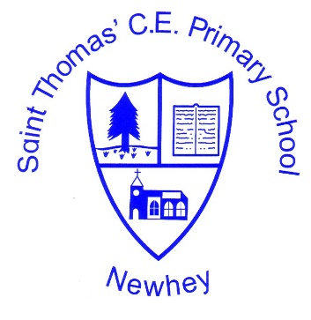
The Little School with the Big Heart
‘With God All Things are Possible’ Matthew 19:26
Art and Design
Intent | Implementation | Impact
At St Thomas Primary School, we value Art and Design as an important part of the children’s entitlement to a broad and balanced curriculum. Art and Design provides the children with the opportunities to develop and extend skills and an opportunity to express their individual interests, thought and ideas.  Art, craft and design embody some of the highest forms of human creativity. A high-quality art and design education should engage, inspire and challenge pupils, equipping them with the knowledge and skills to experiment, invent and create their own works of art, craft and design. As pupils progress, they should be able to think critically and develop a more rigorous understanding of art and design. They should also know how art and design both reflect and shape our history, and contribute to the culture, creativity and wealth of our nation. | The teaching and implementation of the Art and Design Curriculum at St Thomas’ School is based on the National Curriculum and linked to a scheme to ensure a well-structured approach to this creative subject.  The children are taught Art following the Chris Quigley Scheme of Work. Areas covered include sculpture, printing, painting, textiles, and collage.  The work of famous local, national and international artists are explored to enhance the children's learning.  Children are given an Art and DT log book to log their progression through school and a sketchbook in KS2 to record observations and review and revisit ideas.  Early Years Foundation Stage  Pupils explore and use a variety of media and materials through a combination of child initiated and adult directed activities. They have opportunities to learn to:  - Explore the textures, movement, feel and look of different media and materials  - Respond to a range of media and materials, develop their understanding of them in order to manipulate and create different effects.  - Use different media and materials to express their own ideas  - Explore colour and use for a particular purpose  - Develop skills to use simple tools and techniques competently and appropriately  - Select appropriate media and techniques and adapt their work where necessary  Key stage 1  Pupils are taught:  - To use a range of materials creatively to design and make products  - To use drawing, painting and sculpture to develop and share their ideas, experiences and imagination  - To develop a wide range of art and design techniques in using colour, pattern, texture, line, shape, form and space  - About the work of a range of artists, craft makers and designers, describing the differences and similarities between different practices and disciplines, and making links to their own work.  Key stage 2  Pupils are taught to develop their techniques, including their control and their use of materials, with creativity, experimentation and an increasing awareness of different kinds of art, craft and design.  Pupils are taught:  - To create sketch books to record their observations and use them to review and revisit ideas  - To improve their mastery of art and design techniques, including drawing, painting and sculpture with a range of materials [for example, pencil, charcoal, paint, clay]  - About great artists, architects and designers in history. | Our Art and Design curriculum is planned to demonstrate progression.  Ongoing assessments take place throughout the year. Teachers use this information to inform future lessons; ensuring children are supported and challenged appropriately. This data is analysed on a termly basis to inform and address any trends or gaps in attainment. Art log books follow the children’s progress through school.  Children in Foundation Stage are assessed within Expressive Arts and Design and their progress is tracked. Age related expectation levels are reported to parents at the end of the reception year.

