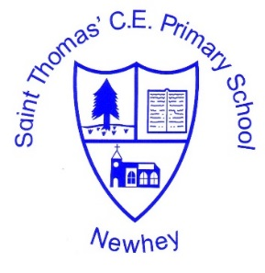
The Little School with the Big Heart
‘With God All Things are Possible’ Matthew 19:26
 | Autumn 1 | Autumn 2 | Spring 1 | Spring 2 | Summer 1 | Summer 2
Class 3 (cycle 1) 2020-2021 | Here We Are.  Abstract Art | D&T Hats (2019 topic) | Animals | D&T | Cityscape art | D&T
Class 3 (cycle 2)  2021-2022 | D&T | Family Life | D&T | Myths and Legends | D&T | A Journey into Space
Class 4 (cycle 1)  2020-2021 | Here We Are.  Royalty | D&T | All Work and No Play | D&T | Impressionism | D&T
Class 4 (cycle 2)  2021-2022 | D&T | Art Deco | D&T | The Renaissance | D&T | Symbolism
Art & Design and Design Technology Milestone 2
Class 3 to focus on the ‘basic’ elements of the planning. Class 4 to focus on Advancing and Deep elements of the planning.
The planning and further support is found on the accompanying Milestone 2 PDF.

