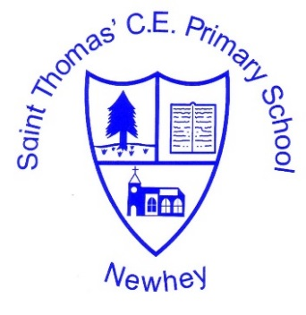
 | Autumn 1 | Autumn 2 | Spring 1 | Spring 2 | Summer 1 | Summer 2
Class 5 (cycle 1) 2020-2021 | Here We Are.  Pop Art | Capturing Conflict | D&T | Amazed by Architecture | D&T | D&T
Class 5 (cycle 2)  2021-2022 | The Art of Anatomy | D&T | Art and Religion | D&T | Exploring Expressionism | D&T
The Little School with the Big Heart
‘With God All Things are Possible’ Matthew 19:26
Art & Design and Design Technology Milestone 3

