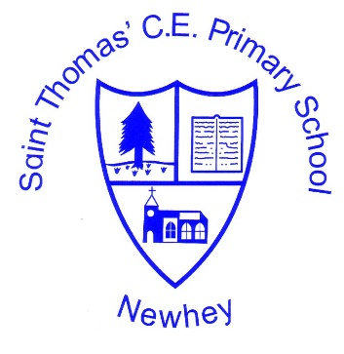
The Little School with the Big Heart
‘With God All Things are Possible’ Matthew 19:26
Design and Technology Vocabulary
KS1 |  | KS2
Class 1 (EYFS/Year 1) | Class 2  (Year 1/Year 2) | Class 3  (Year 2/year3) | Class 4  (Year 4/year 5) | Class 5  (year 5/year 6)
Milestone 1  structure balanced stable free-standing brace base annotate centre of gravity rigid properties construct slab  nature beam column labelled diagram  combined automatically fluency accurate  manufactured adapt refine inspiration purpose user prototype dam  protect solid mortar hollow  connected arranged bond remove  balanced earthquake architects foundations  automatically rear guide bridge rotating  horizontal vertical diagonal attach  transparent opaque rigid pivot  fulcrum force input output  mechanism chassis grown reared caught processed food seasonal food harvest  food poisoning prepare stored |  | Milestone 2  device  app-enabled  respond  annotate  automatically  fluency  inspiration  purpose  user  prototype  LED  conductive  adhesive  exploded diagram  illuminate  enhance  pivot  fulcrum  linear  rotary  reciprocating  oscillating  linked lever mechanism  pneumatic  compressed  pressure  hydraulic  piston  hollow cylinder  reciprocating  rigid  truss  distribute  strut  joining plate  pioneer  chord  pier  strength  stability  variety  purpose  contain  conjunction  external  aspects  parts  coordinates  assemble  accurate  nutrients  pulses  wholegrain  bacteria  preserve  refrigerated |  | Milestone 3  Artificial Intelligence  sensor  annotate  component  detect  automatically  fluency  inspiration  purpose  user  prototype  rotary  propeller  combined  perfected  ellipse  parabola  assemble  technique  construct  extend  assemble  combine  circumference  mechanical advantage  physicist  gear train  interlock  mitre gear  linear  reciprocating  vice versa  dwell  eccentric circle  accurate  perishable  infectious  compost  perennial  annual

